Gabriel Richards

Applied Machine Learning - 44670-80/81

April 2025

1. 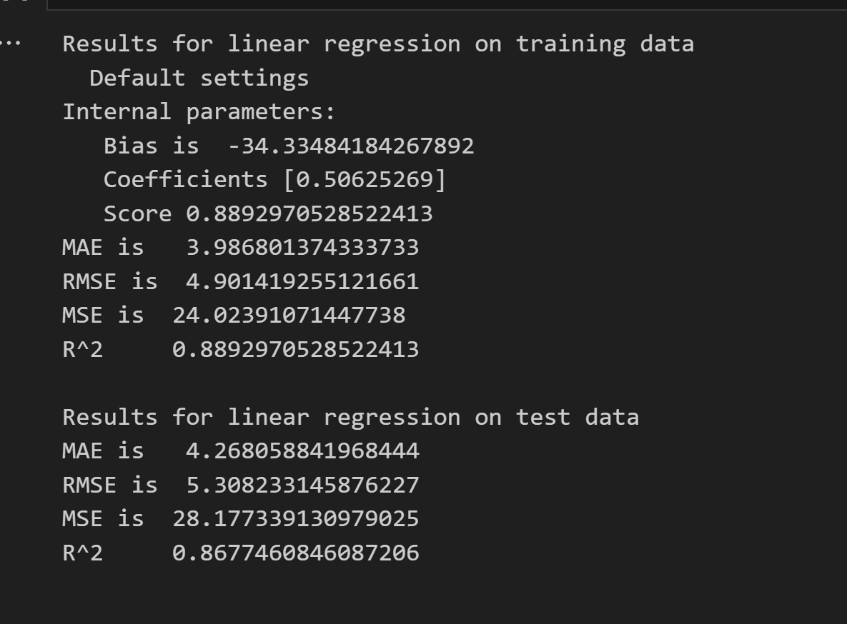A screenshot of a computer program

   AI-generated content may be incorrect.
2. The pipeline clearly tuned down the error with lower MAE, RMSE, and MSE errors. The R^2 is about .05 higher too, bringing it to nearly 0.92.
3. 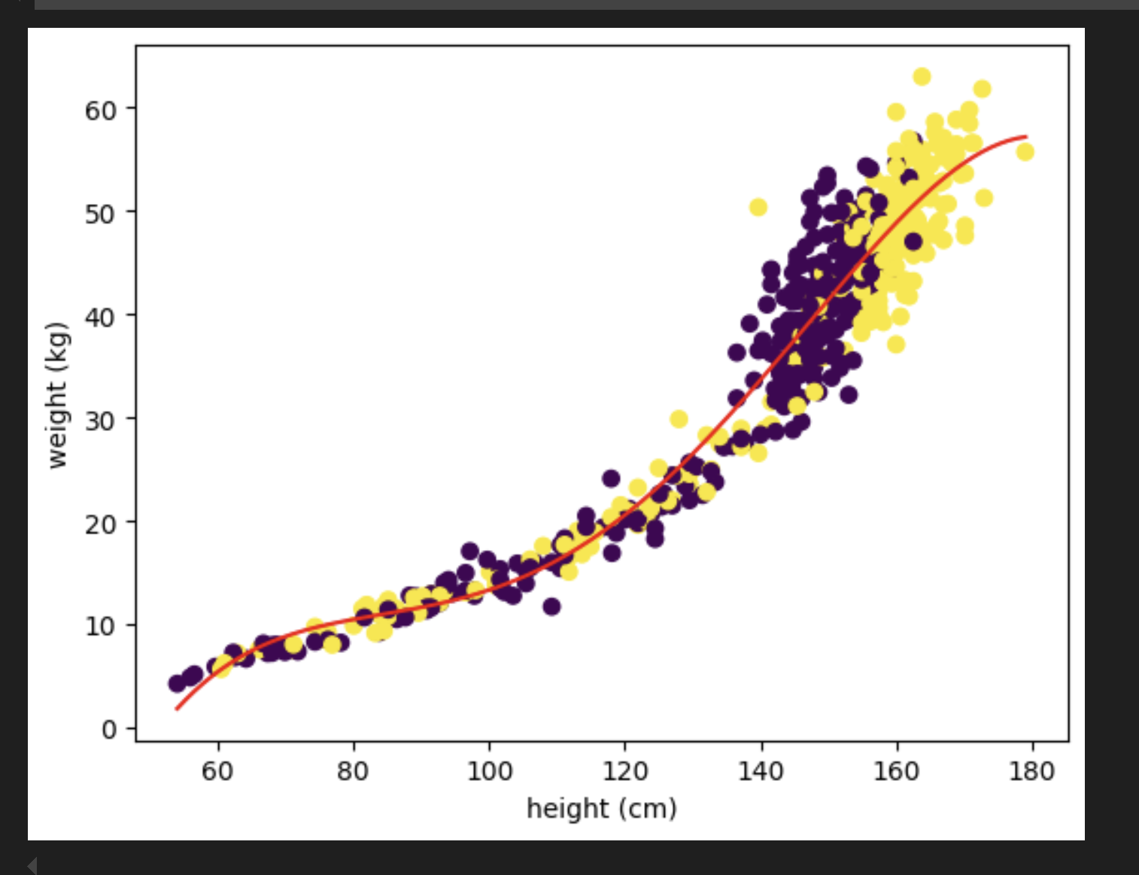
4. A computer screen shot of a computer code

   AI-generated content may be incorrect.
5. To decide on appropriate limits, I would
   1. set the bottom limit as 0 on both for starters – and then if I could verify the set was adults only, conduct a search to see what the shortest/lightest recorded adult values were
   2. search online to find the heaviest/tallest recorded weights for humans, and then add a ~5% buffer. Never know when the next heavier/taller person will show up!
6. 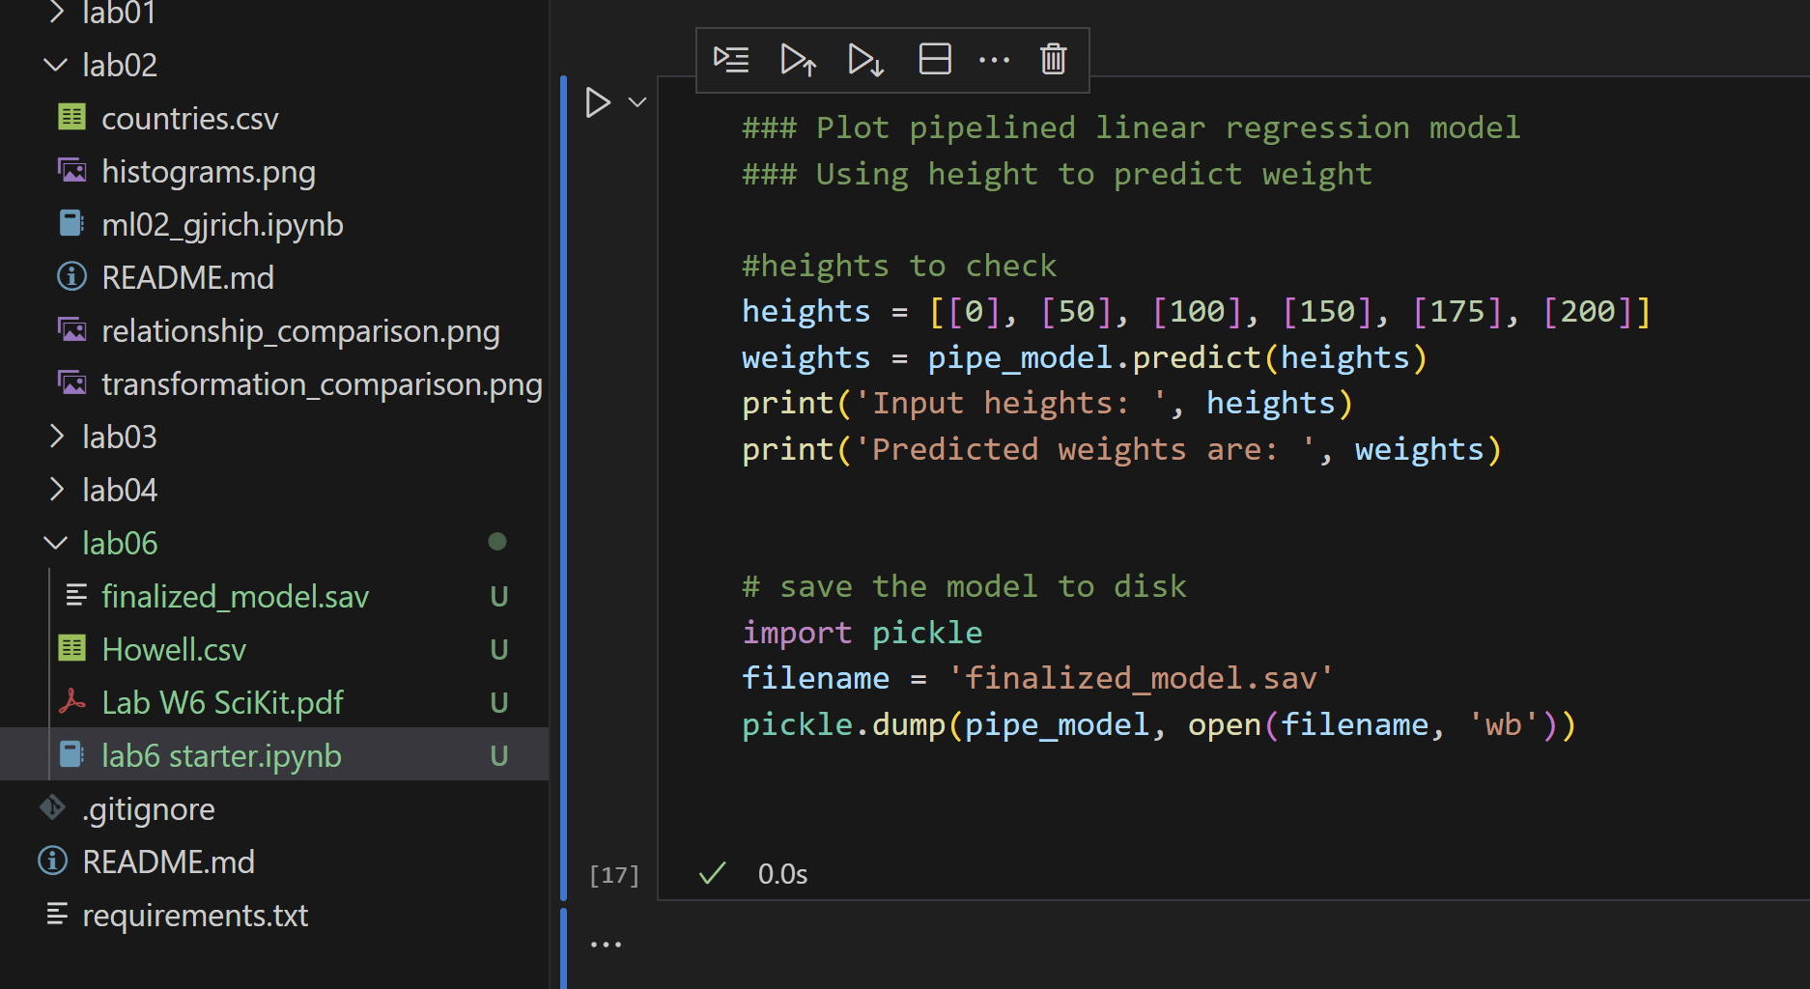
7. A screenshot of a computer

   AI-generated content may be incorrect.Yes, the values clearly match those in number 4.
8. 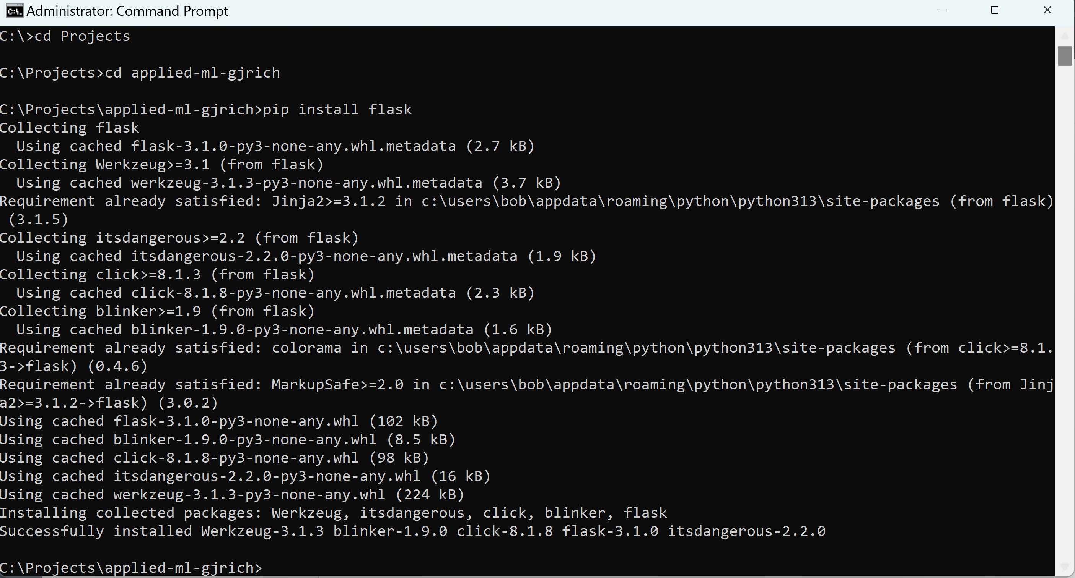
9. 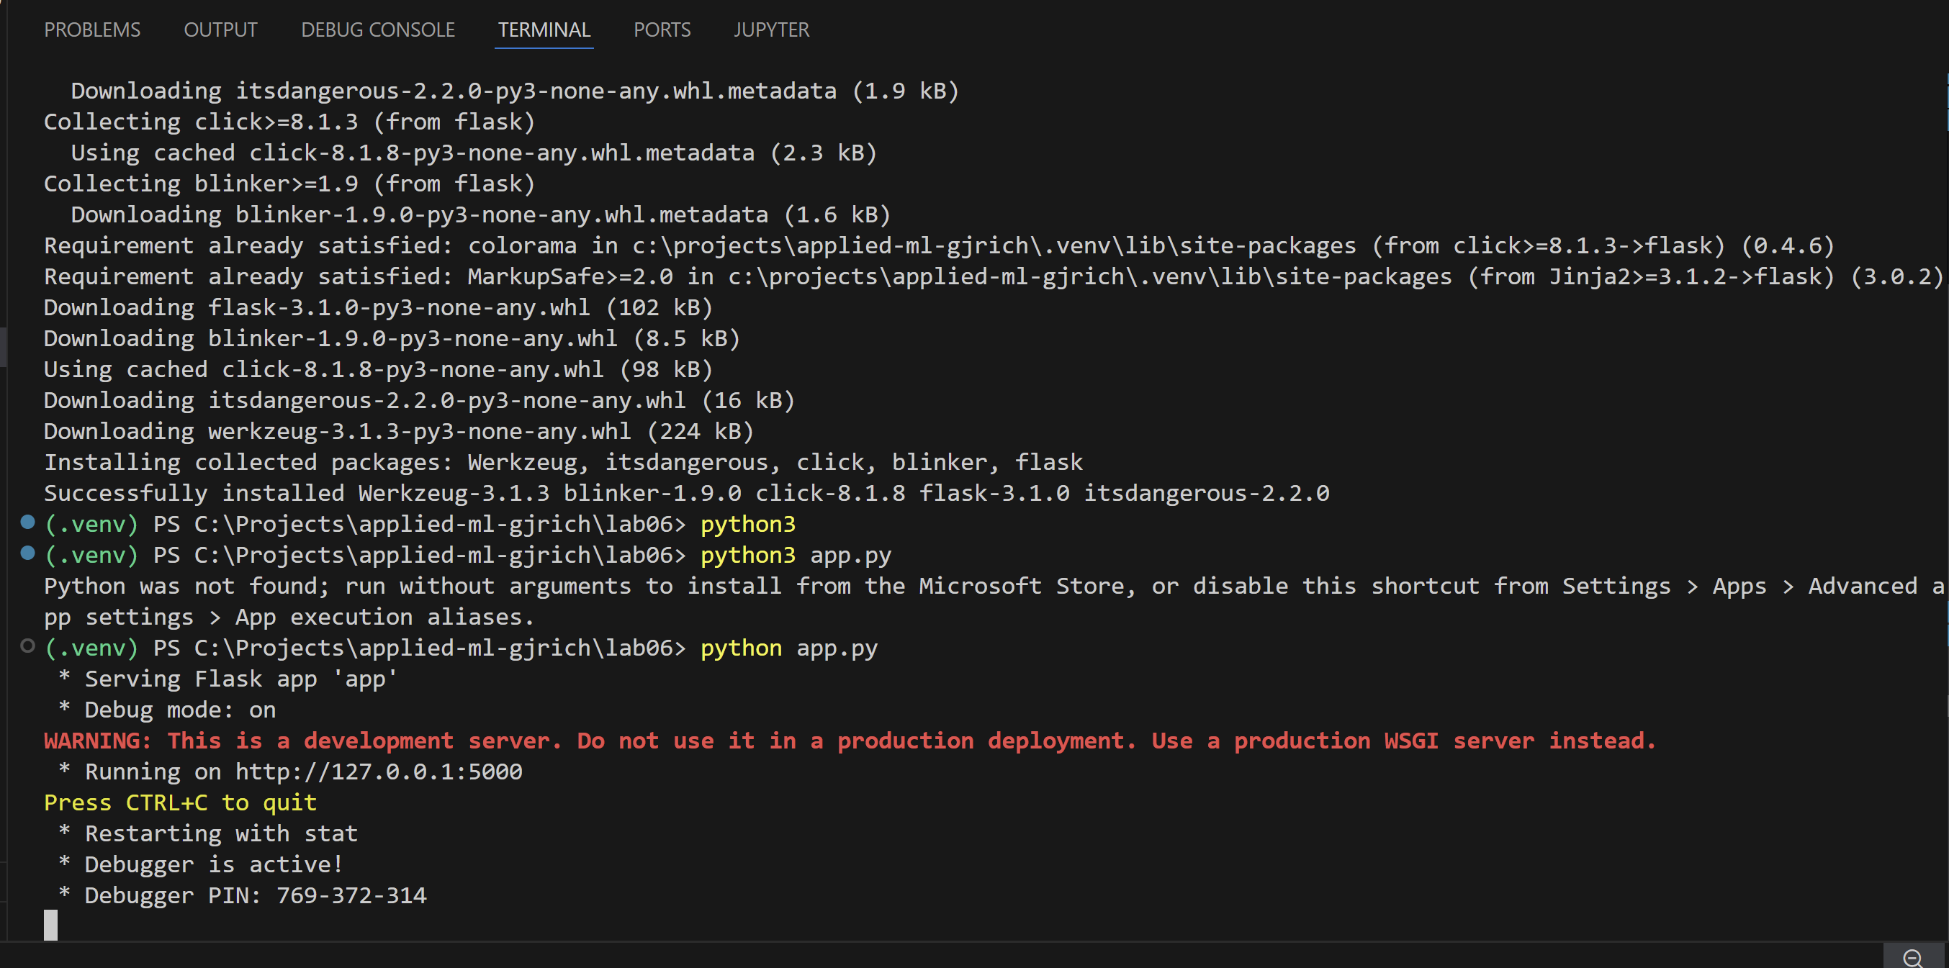
10. Here’s the list:
    1. <http://127.0.0.1:5000/weight>
       1. Bad Request Missing height query parameter
    2. <http://127.0.0.1:5000/weight?height=33.3>
       1. { "height": 33.3, "weight": -25.86060989826653 }
    3. <http://127.0.0.1:5000/weight?height=0>
       1. { "height": 0.0, "weight": -166.29034127566825 }
    4. <http://127.0.0.1:5000/weight?height=50>
       1. { "height": 50.0, "weight": -1.3934699237888282 }
    5. <http://127.0.0.1:5000/weight?height=100>
       1. { "height": 100.0, "weight": 13.326036231749782 }
    6. <http://127.0.0.1:5000/weight?height=150>
       1. { "height": 150.0, "weight": 41.40189303869 }
    7. <http://127.0.0.1:5000/weight?height=175>
       1. { "height": 175.0, "weight": 56.42986106265152 }
    8. <http://127.0.0.1:5000/weight?height=200>
       1. { "height": 200.0, "weight": 44.77557652322908 }
11. Reviewing screenshots from submission 4 and 7, they do!